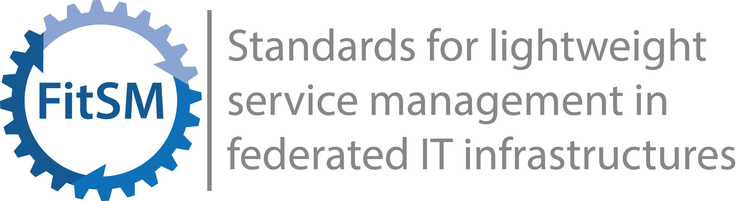

Sample: Corporate Level SLA
This document is a sample Corporate Level SLA. Version 1.0 (2014-02-21)

Comments & usage guidance
- This sample was created to give an idea of how a Corporate Level SLA could look. All contents are exemplary, and the sample may not fully reflect all contents and topics required in a given scenario in practice.
- Corporate Level SLAs are generic documents that cover all SLAs and Services offered by a provider. They work well for situations with less mature services or where customer groups do not have specific or variable service level demands.
- A good approach in introducing IT Service Management can be to start with a Corporate Level SLA covering generic guarantees and conditions for all services, and replacing it with more specific SLAs later.
- For this sample and its contents, the terminology (terms and definitions) according to FitSM-0 applies.

This file is part of the FitSM series of standards for lightweight service management in federated IT infrastructures. It is intended to form the basis of documentation for those implementing (IT) service management following the FitSM approach or related frameworks. It may be edited to fit the needs of the specific area of application.
For more information on FitSM visit www.fitsm.eu.
This work is licensed under a Creative Commons Attribution 4.0 International License.

Corporate Level SLA

General
This corporate service level agreement (SLA) is valid for all IT services provided to support business processes according to the current valid IT service catalogue, if no other agreements are in place. The Corporate Level SLA may be extended or replaced by specific SLAs.

Service delivery & operating times
IT services according to the service catalogue are in general delivered during 24 hours per day, 7 days per week (i.e. 365 days or 8,760 hours), to seamlessly support business operations. Planned and announced interruptions may reduce the effective operating time of a service.
Services, for which even a short downtime has significant impact on business operations, are marked in the service catalogue as either a high-criticality service or a medium-criticality service.

Overall availability target
For each service provided, the minimum annual availability target is 99.5%, independent from the criticality of the service. This means that in one year, the service must not be unavailable for more than 43 hours, if the effective operating time is 8,760 hours. Planned and agreed interruptions (e.g., for maintenance) are not considered as unavailability, since they are not part of the effective operating time.

Planned interruptions, incidents & support
For planned interruptions and (unplanned) incidents, the following targets apply:
- High-criticality services:
  - Planned interruptions only on non-business days
    - Maximum of 4 planned interruptions per year
    - Maximum duration of planned interruption: 1 hour
  - Support and incident handling 24 hours per day, 7 days per week
  - Target resolution time in case of incidents: less than 4 hours

- Medium-criticality services:
  - Planned interruptions only on non-business days
  - Support and incident handling between 8:00 and 18:00 on Mondays to Fridays
  - Target resolution time in case of incidents: less than 1 working day

- All other services:
  - Planned interruptions only on non-business days or between 18:00 and 8:00
  - Support and incident handling between 8:00 and 18:00 on Mondays to Fridays
  - Target resolution time in case of incidents: depending on the individual priority according to incident prioritization guidelines – up to 3 business days (less than 2 or 1 business days in more urgent cases)
Any planned interruption will be announced in advance via the change schedule and agreed communication channels.
Any incident reported through approved channels will be acknowledged and reacted upon within less than 120 minutes (target reaction time) during support hours. To accelerate the response to critical incidents, users recognizing a potentially critical or major incident are obliged to report this incident through dedicated emergency channels, allowing for a target reaction time of less than 20 minutes.

Document control
Document ID | [Unique document identifier]
Document title | Corporate Level SLA
Definitive storage location | [Storage location, e.g. URL of the file on a server or document management system]
Document owner | [Name of the person primarily responsible for maintaining and reviewing this document]
Version | [Version]
Last date of change | [Date]
Next review due date | [Date]
Version & change tracking | [Version history & simple change log]

